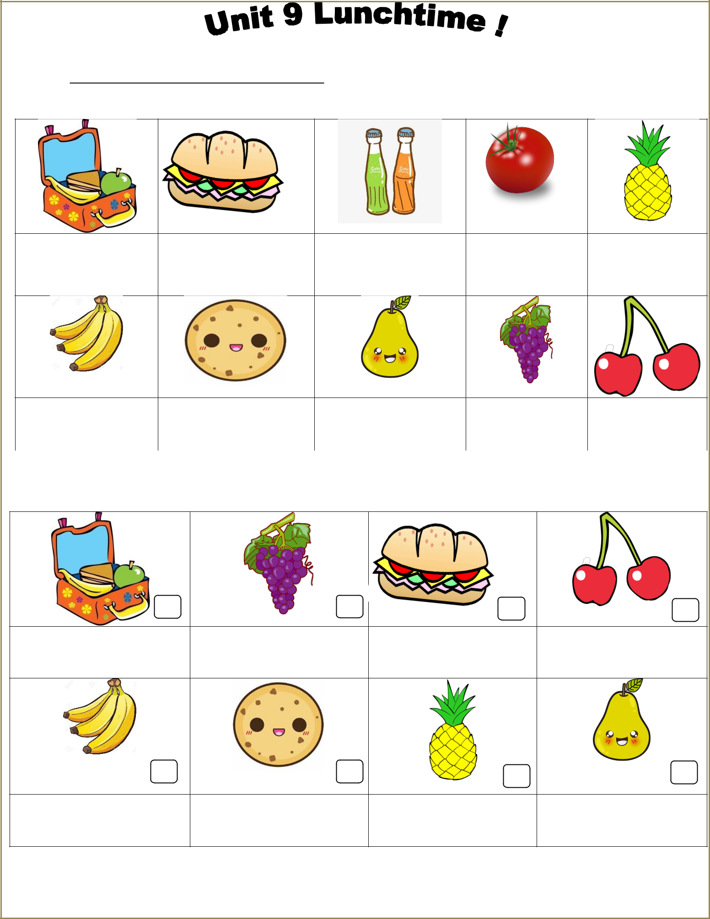**TIẾNG ANH LỚP 2 - TUẦN 23- NGÀY 14/4/2020**

**HỌ VÀ TÊN: ……………………………………….**

Exercise 1 Write the missingletters

|  |  |  |  |  |
| --- | --- | --- | --- | --- |
| lun _ _ box | _ _ nd w_ ch | _ _ inks | tom _ _ _ | pineapp _ _ |

|  |  |  |  |  |  |  |  |  |
| --- | --- | --- | --- | --- | --- | --- | --- | --- |
| ban _ _ as | | cook _ _ | | | | _ _ _ r | gr _ p_ s | _ _ erries |
|  |  | |  |  |  |  |  |  |
|  | Exercise 2 Read and tick ( ✓) or cross (✗) | | | | |  |  |  |
|  |  |  |  |  |  |  |  |  |

|  |  |  |  |
| --- | --- | --- | --- |
| a) I have a lunchbox. | b) I have grapes. | c) I have a tomato. | d) I have cherries. |

|  |  |  |  |
| --- | --- | --- | --- |
| e) I have bananas. | f) I have a cookie. | g) I have an apple. | h) I have a pear. |

pg. 1

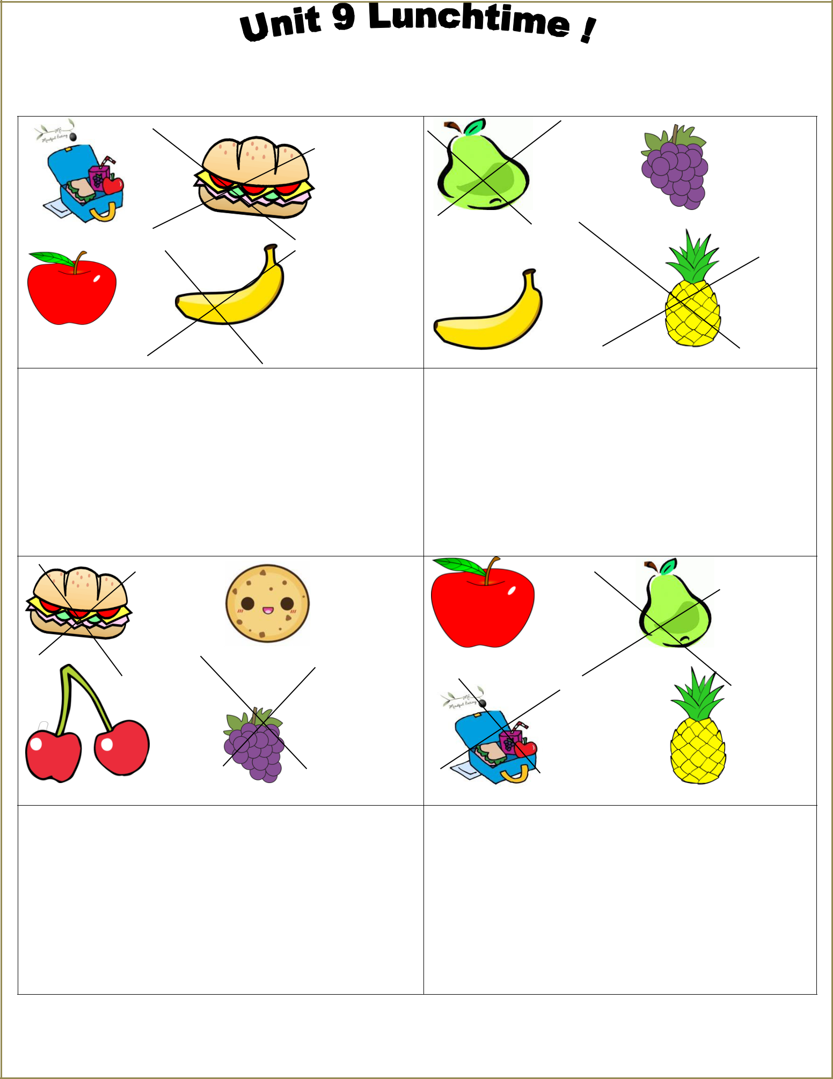

Exercise 3 Look and write

1. I have an apple and a lunchbox.

I don’t have a sandwich and a banana.

2. I have ______________________

I don’t have _______________________.

3.I have ______________________

I don’t have _______________________.

4.I have ______________________

I don’t have _______________________.

pg. 2

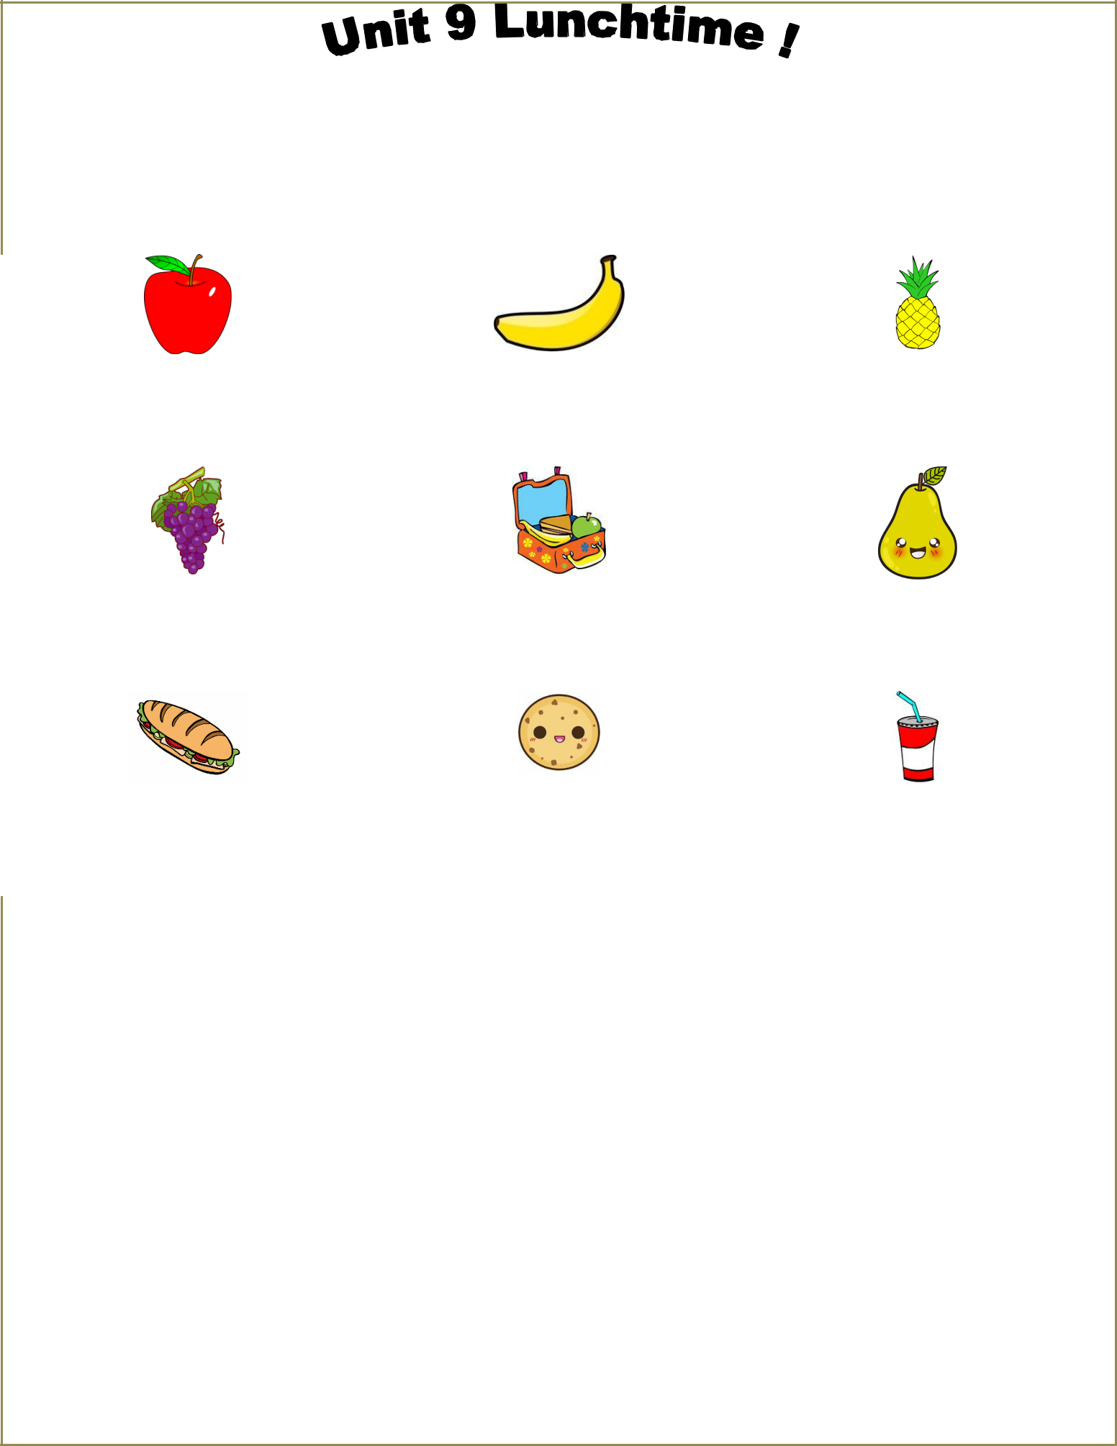

Exercise 4 Look and write

|  |  |  |  |  |  |  |  |  |  |  |  |  |  |  |  |  |  |  |
| --- | --- | --- | --- | --- | --- | --- | --- | --- | --- | --- | --- | --- | --- | --- | --- | --- | --- | --- |
|  |  |  |  |  |  |  | Yes, I do. | | |  |  | No , I don’t | |  |  |  |  |  |
|  |  |  |  |  |  |  |  |  |  | | |  |  |  |  |  |  |  |
|  |  |  |  |  | |  |  |  |  | | | |  |  | |  |  |  |
|  |  |  |  |  | |  |  |  |  | | | |  |  | |  |  |  |
|  | a) Do you have a pear ? | | | | |  | b) Do you have a banana? | | | | | |  | c) Do you have a sandwich? | | | | |
|  | *…………………………………….* | | | | |  | *…………………………………….* | | | | | |  | *…………………………………….* | | | | |
|  |  |  |  |  | |  |  |  |  | | | |  |  | |  |  |  |
|  |  |  |  |  | |  |  |  |  | | | |  |  | |  |  |  |
|  | e) Do you have apples ? | | | | |  | f) Do you have a lunchbox ? | | | | | |  | g) Do you have a pear ? | | | | |
|  | *…………………………………….* | | | | |  | *…………………………………….* | | | | | |  | *…………………………………….* | | | | |
|  |  |  |  |  | |  |  |  |  | | | |  |  | |  |  |  |
|  |  |  |  |  |  |  |  |  |  |  |  |  |  |  |  |  |  |  |
|  | h) Do you have a sandwich ? | | | | |  | i) Do you have a banana ? | | | | | |  | j) Do you have a drink ? | | | | |
|  | *…………………………………….* | | | | |  | *…………………………………….* | | | | | | *…………………………………….* | | | | | |
|  |  |  |  |  | |  | |  |  |  |  |  |  |  |  |  |  |  |
|  |  |  |  |  | | | |  |  |  |  |  |  |  |  |  |  |  |
|  |  |  |  | Exercise 5 Read and match | | | |  | |  |  |  |  |  |  |  |  |  |
|  |  |  |  | | | |  |  |  |  |  | | |  |  |  |  |  |
|  |  | a) What do you have ? | | | | |  |  |  | 1) | Yes, I do. | | |  |  | a) |  | |
|  |  |  | | | | | | |  |  | | | |  |  |  |  | |
|  |  | b) Do you have a sandwich ? | | | | | | |  | 2) I have a biscuit. | | | |  |  | b) |  | |
|  |  |  | | | | |  |  |  |  |  | | |  |  |  |  | |
|  |  | c) What does she have ? | | | | |  |  |  | 3) | No, he doesn’t. | | |  |  | c) |  | |
|  |  |  | | | | |  |  |  |  |  | | |  |  |  |  | |
|  |  | d) Does he have a drink ? | | | | |  |  |  | 4) | She has an apple. | | |  |  | d) |  | |
|  |  |  | | | | |  |  |  |  |  | | |  |  |  |  | |
|  |  | e) What does he have ? | | | | |  |  |  | 5) | Yes, she does. | | |  |  | e) |  | |
|  |  |  | | | | | | |  |  | | | | | |  |  | |
|  |  | f) Does she have an orange ? | | | | | | |  | 6) He has two sandwiches. | | | | | | f) |  | |
|  |  |  |  |  |  |  |  |  |  |  |  |  |  |  |  |  |  |  |
|  |  |  |  |  |  |  |  |  |  |  |  |  |  |  |  |  |  |  |
|  |  |  |  |  |  |  |  |  |  |  |  |  |  |  |  |  |  |  |

pg. 3

**TIẾNG ANH LỚP 2 - TUẦN 24**

**HỌ VÀ TÊN: …………………………..**

Exercise 6 Put the words in the correct order to make sentences.

a) My sister – a banana - has

*………………………………………………………………………*

b) I – have – don’t – a sandwich

*………………………………………………………………………*

c) She – a biscuit – has

*………………………………………………………………………*

d) drinks – My brother – has

*………………………………………………………………………*

e) What – you – do – have ?

*………………………………………………………………………*

f) I – grapes – don’t – have

*………………………………………………………………………*

g) She – have – doesn’t – a lunchbox

*………………………………………………………………………*

h) Do – have – a pear – you ?

*………………………………………………………………………*

i) Tony – two – sandwiches – has

*………………………………………………………………………*

j) What – she – have – does ?

*………………………………………………………………………*

k) Does – an orange – he – have ?

*………………………………………………………………………*

l) My mom – doesn’t – a pineapple – have

*………………………………………………………………………*

m) I – biscuits – don’t – have

*………………………………………………………………………*

pg. 4